3-Phase Brushless DC Motor Built-in Driver Specification
for B2418M(12~24VDC)
______________________________________________________________________________________________________
Features and Benefits 特点和优点
▪ PWM speed adjust PWM速度调节
▪ FG outputs FG速度反馈输出
▪ Standby mode 待机模式支持
▪ Lock detect protection 带堵转保护功能
▪ Over current protection 带过流保护功能
▪ Low power consumption &high efficiency. 高效率低功耗
Lead wires and Functions 引线介绍和功能:
Red wire : VM--Motor Working power supply电机工作电源电压.
Green wire: FG---Motor speed feed-back, output pulse signal速度反馈信号,脉冲功能输出
Yellow wire: CW/CCW—Motor rotate direction control input 电机转向控制输入信号
Black wire： GND---电机电源负极.
Blue wire： PWM--- Pulse-Width Modulation for Motor speed adjust 脉宽调制信号用于电机调速控制.
Electrical characteristics 电性参数
NO. | 信號SIGNAL | I/O | 規格SPECIFICATIONS | 備注NOTE
1 | Vm | IN | DC 8V -26V | 電源正POWER
2 | FG
2 | VOH | OUT | 5V (6.0 V max) | Hall Signal Pulse Outputs
2 | VOL | OUT | 0V (0.5V max) | Hall Signal Pulse Outputs
2 | FG Signal Current | OUT | 2mA max | Hall Signal Pulse Outputs
2 | Pulse Outputs of Rotation | OUT | 6 Pulse/cycle | Hall Signal Pulse Outputs
3 | CW/CCW
3 | Input Voltage Range | IN | 0~5v（TTL 标准） | High---motor CCW  Low---motor CW
3 | VIH | IN | 5.5V>VIH >3.5V | High---motor CCW  Low---motor CW
3 | VIL | IN | 0.7>VIL>GND | High---motor CCW  Low---motor CW
4 | GND(Black wire) | IN | Power Ground
5 | PWM 控制
5 | Input Voltage Range | IN | 0~5v（15K-25K） | Low power side is available
5 | VIH | IN | 5.5V>VIH >2.7V | Low power side is available
5 | VIL | IN | 0.5>VIL>GND | Low power side is available

Motor Speed Control 电机速度控制

▪PWM—脉宽控制
▪Frequency 15kHz—25kHz；
▪Duty：The working duty rang at 8%~100%, if duty low than 8%, motor will be stop, if duty=100%, motor will be full
speed running，PWM is low power side is available.
正占空比：8%-100%调速. Duty<8%电机停转. Duty=100%时电机全速转动，
PWM的低电平时电机全速转动。

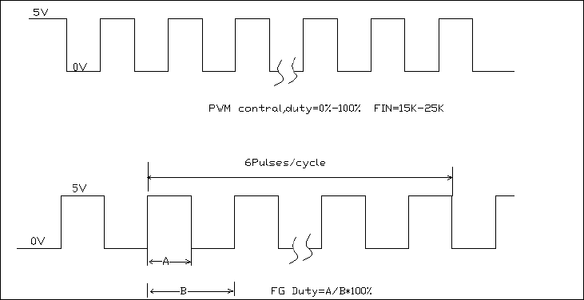
PWM的高低平对电机速度控制有效

Note： When the motor is running, if want to switch rotate direction, please stop motor first then set CW/CCW and restart motor
注意：当需要切换转向时，请先停止电机，在切换CW/CCW后重新启动电机.
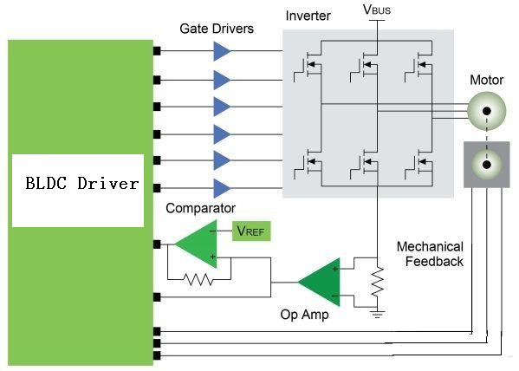
Controller Diagrammatic Drawing 控制器示意图:

Input/Output Pin Structures:
Input and Output Pin Structures 输出/输入结构电性结构:
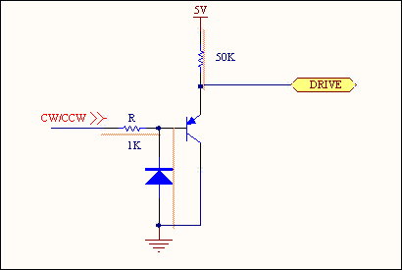
VM: CW/CCW:
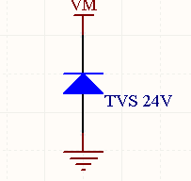

FG: PWM:
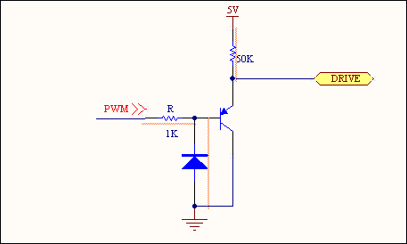
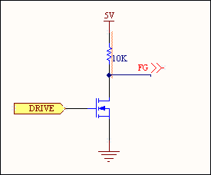

Typical Application Circuit (Connection) 典型应用接线图
